For Immediate Release: Contact: Scott Sylvester
619 699 9190 Mobile
scott@a-bus.com

A-BUS Partners Introduce Bluetooth Technology

Sydney NSW, AUSTRALIA, Wednesday, 25 September 2013 -- LeisureTech announces the introduction of Bluetooth technology to A-BUS multi-room audio.

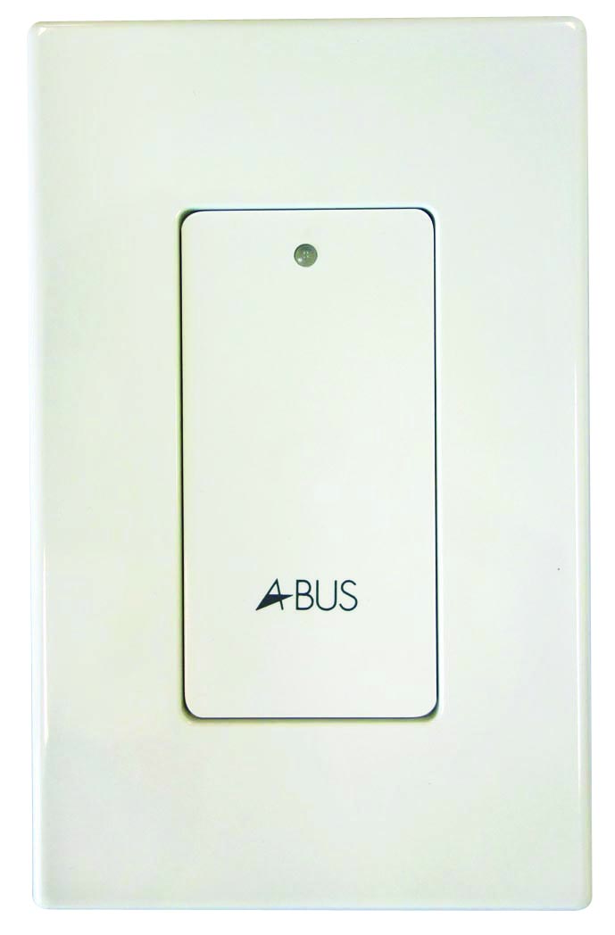
Four A-BUS partners, Channel Vision, Eaton, Forté and Russound have now introduced a Bluetooth LIM (Local Input Module) to their A-BUS product ranges. Bluetooth is a natural partner for A-BUS. The amplifiers are located in each room unit, either as keypad or incorporated in the speakers, instead of centrally located, as is the case with traditional MRA systems. This very unique feature allows A-BUS to provide a local source input in each room. Now with the high mobility of music libraries typically streaming and stored in smart phones or tablets, an A-BUS LIM will allow homeowners and their families to play their music content wirelessly in the room or area of choice.

Andrew Goldfinch inventor of A-BUS CAT5 technology states, “The new Bluetooth LIM demonstrates how well the A-BUS format fits in with new technologies. Music is now mobile; it is in every ones pocket. A local input is likely to become just as important as multi-source capability around the home. We also have a product that continues to demonstrate the elegant simplicity of A-BUS. The Bluetooth receiver receives its power from the CAT5 cable eliminating the need access power locally and the mess that ancillary products often produce. The LIM is simply spliced into the CAT5 line between the hub and room unit. To operate is just as simple. When paired, the Bluetooth LIM automatically overrides the audio source from the central hub.”

Page 2
LTE Release- A-BUS Partners, Release Bluetooth LIM
25 September 2013

Scott Sylvester, US Operations Manager said, “A-BUS is well known for its flexibility. Systems can be designed from a wide range of components manufactured by its partners with the A-BUS logo. The new Bluetooth LIM’s can be retrofitted to any of the many thousands of A-BUS systems installed in homes in America regardless of brand.”

About A-BUS®
A-BUS is a unique, proven technology for multi-room audio that utilizes a single Cat-5 cable to carry signal, data, infrared, status and power. This ingenious approach places the amplifiers closer to the speakers, enabling superior sound quality, increased flexibility, simpler installation, consumer-friendly operation, energy savings and greater affordability. A-BUS is patented in Australia, New Zealand, Canada, Mexico and the United States.

About LeisureTech Electronics
Founded in 1977, LeisureTech Electronics is a global OEM technology provider, A-BUS Licensee and OEM manufacturer for the residential systems market. LTE founder Andrew Goldfinch teamed up with Len Andrews in 1989, and in 1997 the enterprising duo invented A-BUS, a revolutionary technology for multi-room audio.

A-BUS launched worldwide in 2000, licensed to leading CE manufacturers, who manufacture components to the “A-BUS Standard’ for inter compatibility, quickly becoming the standard for affordable multi-room audio applications in the US. In 2005, LeisureTech opened its own manufacturing facility to provide A-BUS OEM products to manufacturers. In 2009, LeisureTech introduced its own range of A-BUS products under Forté brand. www.leisuretech.com.au; www.a-bus.com.

# # #

